LIFEGUARD VACANCY £10 AN HOUR
Weekends & School Holidays
For private hirers and pool parties up to 20 bathers
Enclosed Pool 15m x 4.5m
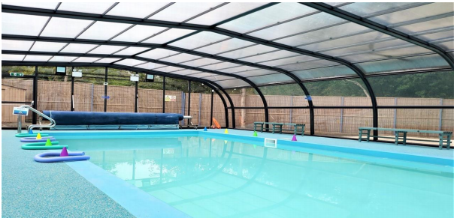

Already a qualified lifeguard?
ALL lifeguard qualifications are deemed acceptable to be a lifeguard at our pool.
Please call us on 07857 658353 or email sbm@ststephens.surrey.sch.uk

Want to be a lifeguard?
We will pay for your training if you are happy to commit to being available as a lifeguard for two years. Please call us on 07857 658353 or email sbm@ststephens.surrey.sch

Please call us on 07857 658353
or email sbm@ststephens.surrey.sch.uk

If you’re interested in hiring our pool
please see the school website
www.ststephens.surrey.sch.uk for details.

