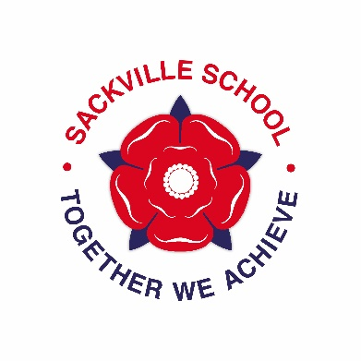
Science in year 7 at Sackville

What are we teaching them?
Autumn term: Cells, particles and space science
Spring term: Reproduction, atoms, elements and compounds, energy
Summer term: Inheritance, acids and alkalis, waves (light and sound)

Homework and Assessment
Homework is set once every 2 weeks and should usually take 30 minutes. It will all be on show my homework.
Assessment is in the form of a test, one per topic

How can you help?
Ensure your child is fully equipped (a calculator is often used)
Monitor Show My Homework and support us with deadlines
Ask questions about topics when they are revising for a test
Contact staff if there are issues

Extra Curricular activities
- Science Club – starting after half term on Wednesdays 3-4pm
- Observatory Open Evenings
  - Bring a telescope, or look through one of ours
  - Dates on website and the Facebook page “Sackville Observatory” (Weds 1st Nov, 6th December, 17th January, 21st February, 21st March)

